RESOLUTION NO. 4-2026
A RESOLUTION OF THE CITY OF LAWRENCE, INDIANA COMMON COUNCIL ESTABLISHING THE FORT HARRISON RIVERFRONT DEVELOPMENT DISTRICT
Whereas, Indiana Code § 7.1-3-20-16(b) and (d) allow for and authorize the issuance of specified, non-transferable permits to sell alcoholic beverages for on-premises consumption only in a restaurant on land or in a historic river vessel within a municipal riverfront development project funded in part with state and city money; and
Whereas, the Fort Harrison Reuse Authority (“FHRA”) is a military reuse authority which was formed and exists under the requirements provided in Indiana Code § 36-7-14.5 et. seq. (the Act”) for the purposes provided and permitted under Indiana statute;
Whereas, the FHRA has previously created an economic development area and which is comprised of the boundaries of the former Fort Benjamin Harrison (“Area”) within City of Lawrence (“City”) which consists of certain property in the City and which is shown on Exhibit A hereto;
WHEREAS, in addition to designating the Area, the FHRA has adopted various economic development plans for the Area, including the Master Reuse Implementation Plan (the “Plan”);
Whereas, The FHRA has requested that the Lawrence Common Council consider the creation of the Fort Harrison Riverfront District (the “District”) as shown on Exhibit B hereto to allow for the issuance of up to fifteen (15) Riverfront Development District Licenses (the “Licenses”) in support of economic development opportunities in the District.
NOW, THEREFORE, BE IT RESOLVED BY THE COMMON COUNCIL OF THE CITY OF LAWRENCE, INDIANA, THAT:
- The area shown on Exhibit B hereto is hereby designated as the Fort Harrison Riverfront Development District.

- The FHRA shall create guidelines for accepting applications for the Licenses and the formulation of recommendations for the issuance of Licenses to the Lawrence Common Council.

- The Clerk is hereby directed to file a copy of this with the permanent minutes of this meeting.

- This resolution shall be in full force and effect from and after its passage and approval by the Mayor.

ADOPTED AND PASSED by the Common Council of the City of Lawrence, Indiana, this 3rd day of August, 2026.

COMMON COUNCIL OF THE CITY OF LAWRENCE, INDIANA

Zach Cramer, President
ATTEST:
_____________________________
Leatrice Adkisson, City Clerk

Presented by me to the Mayor of the City of Lawrence, Indiana, this _____ day of ________________, 2026 at __:__ _.m.

Leatrice Adkisson, City Clerk

Signed and approved by me, the Mayor of the City of Lawrence, Indiana, on this ____ day of ______________, 2026 at __:__ _.m.

Deborah Whitfield, Mayor

[SIGNATURE PAGE TO RESOLUTION __]
[A RESOLUTION OF THE CITY OF LAWRENCE, INDIANA COMMON COUNCIL ESTABLISHING THE FORT HARRISON RIVERFRONT DEVELOPMENT DISTRICT]

EXHIBIT A
Map of Fort Harrison Reuse Authority Area
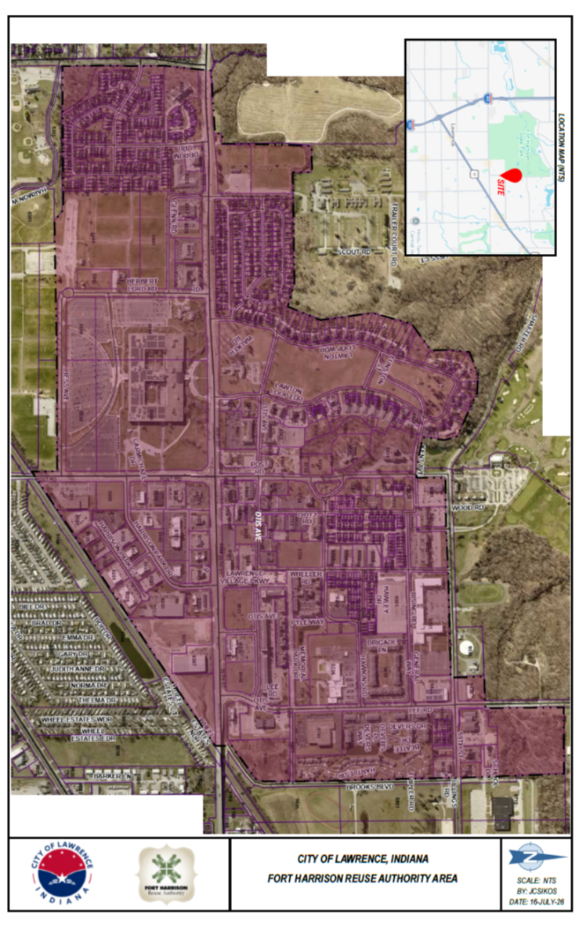

EXHIBIT B

Fort Harrison Riverfront Development District

