RESOLUTION NO. 5-2026
A RESOLUTION OF THE CITY OF LAWRENCE, INDIANA COMMON COUNCIL ESTABLISHING THE OAKLANDON ROAD RIVERFRONT DEVELOPMENT DISTRICT
Whereas, Indiana Code § 7.1-3-20-16(d) allows for and authorizes the issuance of specified, non-transferable permits to sell alcoholic beverages for on-premises consumption only in a restaurant on land or in a historic river vessel within a municipal riverfront development project funded in part with state and city money; and
Whereas, the Lawrence Common Council has established under Indiana Code § 36-7-14 the Redevelopment Commission of the City of Lawrence, Indiana;
Whereas, the Redevelopment Commission of Lawrence Indiana, has previously established the Sunnyside to Oaklandon Economic Development Area (the “Area”) and an Economic Development Plan for said Area pursuant to Resolution No.2-2025 passed on October 16, 2025, and approved by the Lawrence Common Council on December 1, 2025. The Area is described on Exhibit A attached hereto and made part hereof; and
Whereas, The Redevelopment Commission has requested that the Lawrence Common Council consider the creation of the Oaklandon Road Riverfront District (the “District”) as shown on Exhibit B hereto to allow for the issuance of up to ten (10) Riverfront Development District Licenses (the “Licenses”) in support of economic development opportunities in the District.
NOW, THEREFORE, BE IT RESOLVED BY THE COMMON COUNCIL OF THE CITY OF LAWRENCE, INDIANA, THAT:
- The area shown on Exhibit B hereto is hereby designated as the Oaklandon Riverfront Development District.

- The RDC shall create guidelines for accepting applications for the Licenses and the formulation of recommendations for the issuance of Licenses to the Lawrence Common Council.

- The Clerk is hereby directed to file a copy of this with the permanent minutes of this meeting.

- This resolution shall be in full force and effect from and after its passage and approval by the Mayor.

ADOPTED AND PASSED by the Common Council of the City of Lawrence, Indiana, this 3rd day of August, 2026.

COMMON COUNCIL OF THE CITY OF LAWRENCE, INDIANA

Zach Cramer, President
ATTEST:
_____________________________
Leatrice Adkisson, City Clerk

Presented by me to the Mayor of the City of Lawrence, Indiana, this _____ day of ________________, 2026 at __:__ _.m.

Leatrice Adkisson, City Clerk

Signed and approved by me, the Mayor of the City of Lawrence, Indiana, on this ____ day of ______________, 2026 at __:__ _.m.

Deborah Whitfield, Mayor

[SIGNATURE PAGE TO RESOLUTION __]
[A RESOLUTION OF THE CITY OF LAWRENCE, INDIANA COMMON COUNCIL ESTABLISHING THE OAKLANDON ROAD RIVERFRONT DEVELOPMENT DISTRICT]

EXHIBIT A

Sunnyside to Oaklandon Economic Development Area

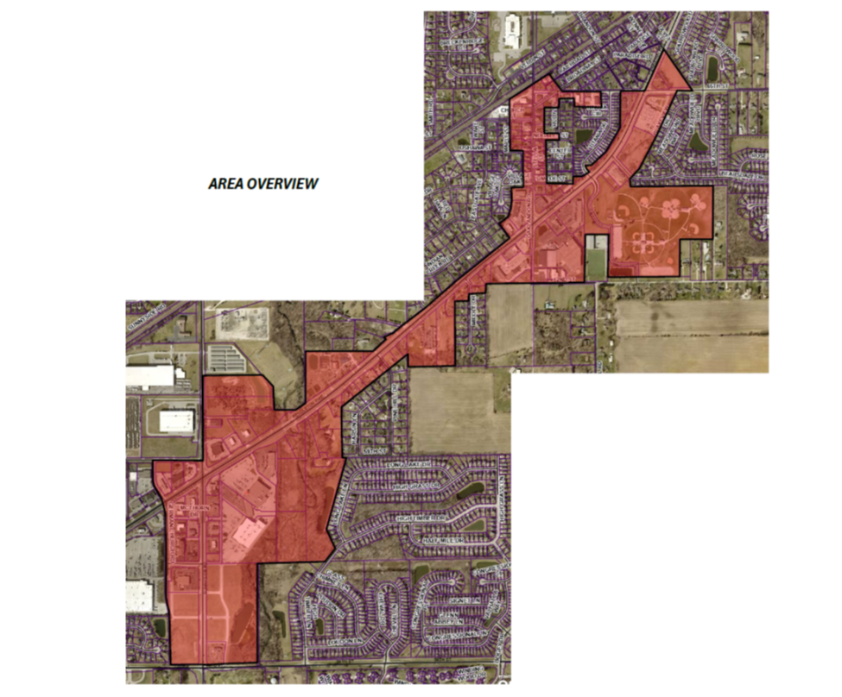

EXHIBIT B

Oaklandon Road Riverfront Development District

