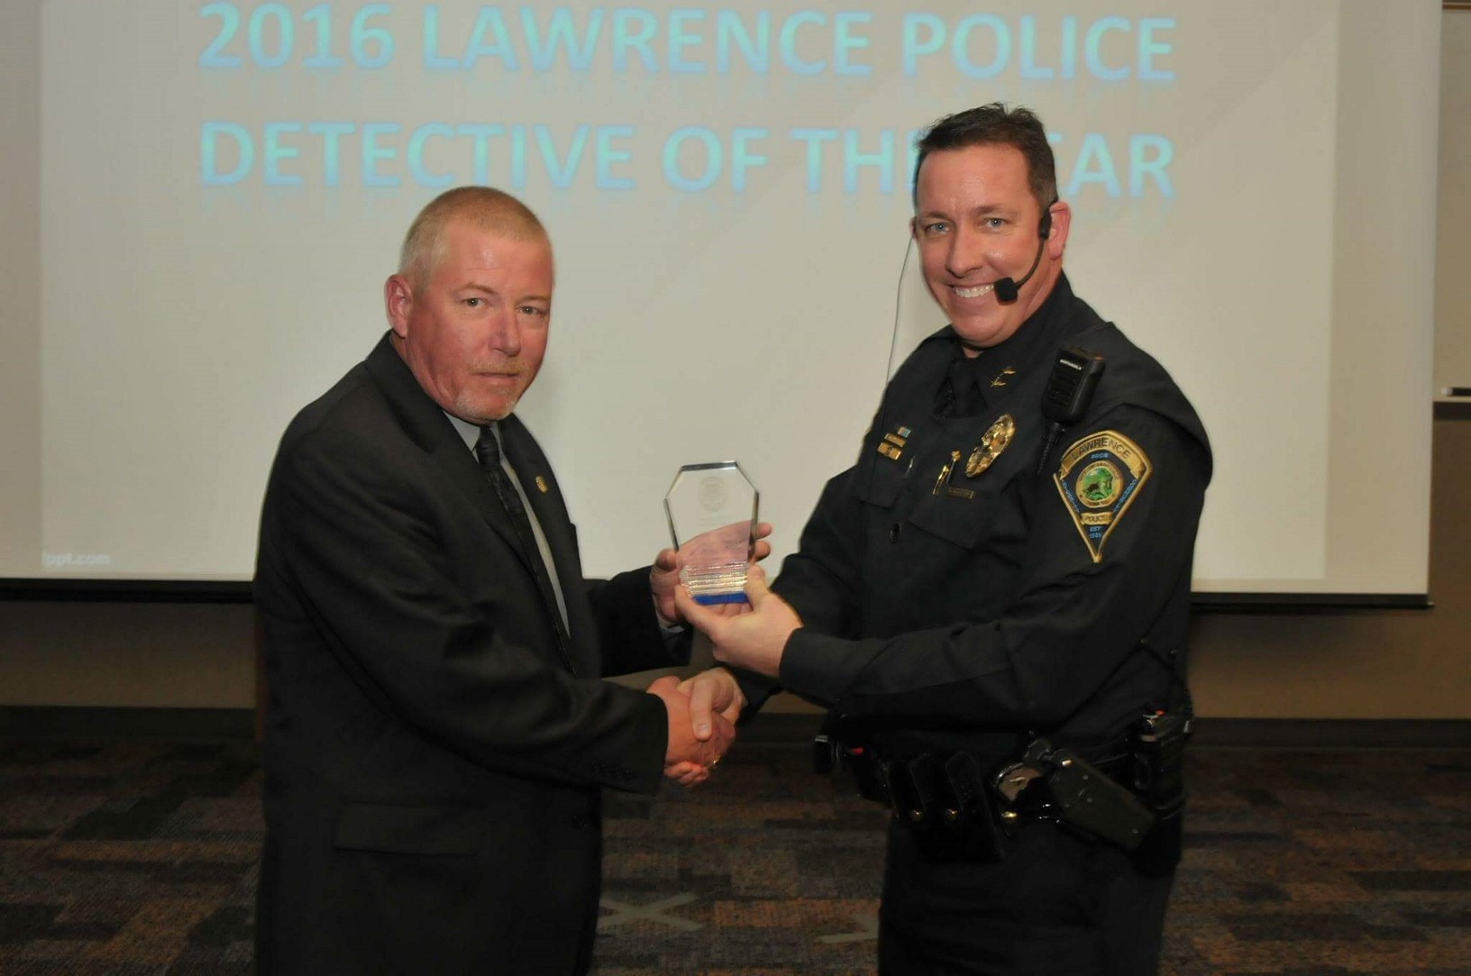
LPD honors Hancock as Detective of the Year
For the 2016 Investigations Division Detective of the Year Award, Captain Mark Osborn selected a "less noticed" detective, in that most of his work goes unnoticed to many, other than by his co-workers, and the victims he works so diligently to resolve their crimes. Most of his cases are not necessarily violent crime-related cases, but nevertheless require tremendous investment of time and effort to investigate and prepare for prosecution.
Detective Scott Hancock is primarily LPD's Retail/Property Crime detective, working numerous cases from local businesses and retailers. In 2016, Detective Hancock had 238 case assignments, with a 66% closure rate on his property crime-related cases. Detective Hancock has the additional responsibility of working Hit and Run cases, and coordinating LPD's Accident Investigations Team. Last year, Detective Hancock oversaw the work and investigation of 146 Hit and Run cases.

Chief Hofmann recently recognized Detective Scott Hancock as the 2016 Detective of the Year.

