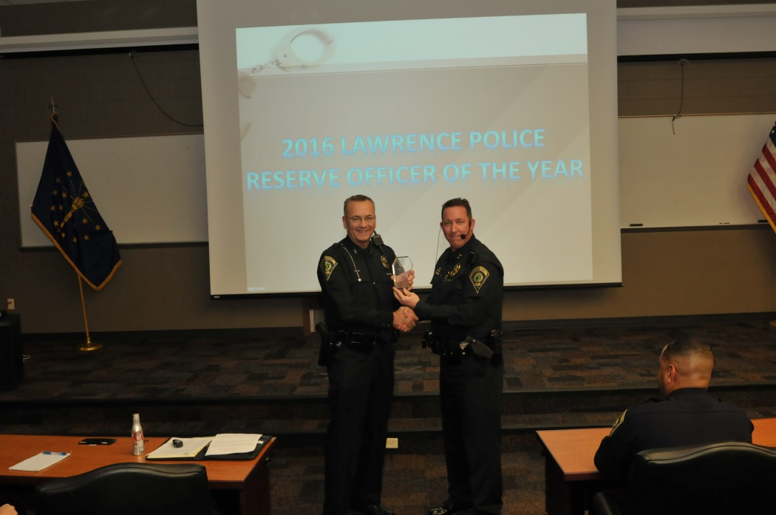

Lushin honored by LPD for service & dedication as a reserve officer

For LPD's 2016 Reserve Officer of the Year, Captain Keith Mathews selected Officer Paul Lushin. He has been with LPD for four years, during which he has exhibited a strong commitment and desire to serve the City of Lawrence and its citizens, demonstrated by his selfless hours of service.

During the past year alone, he has donated 480 hours of his time working the road, serving and protecting the citizens of our city. During those hours, he responded to 268 radio runs, issued 253 citations, and 159 warnings. Officer Lushin always demonstrates a professional attitude and strong work ethic, and he is well-respected by both his supervisors and fellow Officers. In addition, he is regularly among the first Reserve Officers to volunteer to fill voids, respond to call-outs, and work tirelessly during special events.

In addition to his normal road patrol duties, Officer Lushin assumed the role of Lawrence Police Explorers Scout program Advisor in January 2016. Under his auspice, the Explorer program has grown to over 20 Explorer Scouts, with an extensive training program to fully prepare every Explorer to support LPD during events. This Officer donated countless hours to the Explorer program, and leveraged private funding to purchase badges, patches, uniforms, equipment, including a bicycle program. He worked extensively to establish relationships with key community supporters, ranging from the Lawrence Township Trustee, Boy Scouts of America, other area Explorer groups, and Lawrence Township Schools, in support of the Explorer program.

