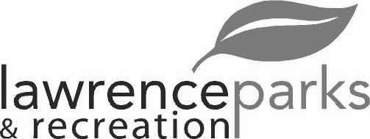
City of Lawrence Board of Parks and Recreation - Regular Meeting
Wednesday, April 11, 2018 – 6:00 pm
Lawrence Government Center
Public Assembly Room

Members present: Jeff Vest, Judy Logsdon, Tom Burns Shawn Denney and Helen Taylor
Staff: Eric Martin and Dina Gee
Guest: None
Meeting was called to order by Jeff Vest at 6:01 pm.
Minutes:
Minutes of the March 14, 2018 meeting were distributed for review and clarification. Jeff entertained a motion to accept the minutes as submitted. Motion was made by Shawn Denney to accept the minutes, seconded by Tom Burns. Motion carried 4-0. Helen Taylor was not there for the vote.
Reports from Parks Director:
The Cultural Arts Group submitted the grant. We will know something by end of month if it will be passed on to full committee. The full committee votes on it at the end of August.
The overtime budget is at 20%. The utility budget will be close.
OYO and Fall Creek little leagues opening day is April 14, 2018. Lawrence Park little league’s opening day is April 28, 2018.
Red Lion tournament runs April 27 – 29, 2018.
The Play Park will be closed through June.
Ron Davies is looking in to hosting a 5k run/walk on July 21, 2018 at Community Park to benefit Young Life.
We have 15 vendors for the Farmer’s Market so far. It will run on Thursdays from 4-7pm.
Board Comment:
Fourth of July meetings should be starting soon.
Lawrence Park little league is up to 230 players but down 30% from last year.
The American Legion owns the property that the War Memorial will be set up on and they will be maintaining the property and security for it.
New Business:
- Jenn Park Demo
The Jenn Park house was demolished today. The remains should be hauled out tomorrow.
- Citizens Group – Sewer Project within Community Park
A week ago, Citizens Group had an obstruction in one of their sewer lines that runs through Community Park. They have sent out for proposals for fixing it but in the meantime they have rerouted the sewage lines so everything will still flow.
Old Business:
- Lee Road Park – Korb Diamond
Park’s department had 60 yards of dirt delivered to fix Korb diamond but will have to wait til the field dries up to process it.
- Faciltiy Rental Fee Revisions
Eric is working on a resolution to send to Legal for approval.
Public Comments:
Adjournment:
Jeff Vest adjourned the meeting at 6:27 p.m.

Secretary Signature: ______________________________________ Date: _____________________________

