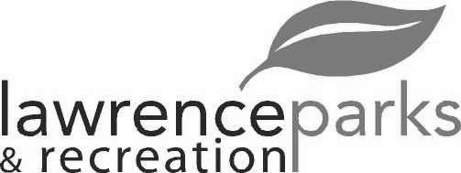
City of Lawrence Board of Parks and Recreation - Regular Meeting
Wednesday, September 12, 2018 – 6:00 pm
Lawrence Government Center
Public Assembly Room

Members present: Jeff Vest, Judy Logsdon, Tom Burns and Helen Taylor
Staff: Eric Martin and Dina Gee
Guest: None
Meeting was called to order by Jeff Vest at 6:00 pm.
Minutes:
Minutes of the August 9, 2018 meeting were distributed for review and clarification. Jeff entertained a motion to accept the minutes as submitted. Motion was made by Tom Burns to accept the minutes, seconded by Helen Taylor. Motion carried 3-0. Judy Logsdon was not there for the vote.
Reports from Parks Director:
The Sterrett Center painting is done. The flooring material is on site and they should be installing it anytime. We should have all the renovations done by mid October.
Lagers in Lawrence is September 29, 2018 from 3pm – 7pm at the Civic Plaza.
Fall Soccer tournament (Pride Cup) is the last weekend in September.
We had some storm damage to our buildings. The adjuster came out and toured our facilities. They will contact us with what will be covered.
We are doing very well financially with this year’s budget. The revenue is at 91%. The only concern is still with the utilities.
Board Comment:
The Board is still concerned about the need for a guard rail along the open ditch alongside Harmon Way. We are looking into straightening the road out in next year’s budget.
The Street Department has patched the pot holes at the Sterrett Center.
Jeff will have about 25 kids in the parks for Indy Do Day on September 28, 2018.
New Business:
- Acceptance of Quote for Playgrounds @ Veterans Memorial Park:
After receiving 3 proposals for the playground equipment, Eric asked the Board to approve the quote from Miracle Midwest . The quote is for $59,320. Tom Burns made a motion to approve the quote, seconded by Helen Taylor. Approval carried 3-0.
- Budget Review and Process for 2019
The 2019 budget proposal will go in front of the Finance board tomorrow night. There is an allocated amount for up to 3% raise for employees. Also proposed is $325,000 for the paving on Harmon Way and $75,000 for playground equipment for Explorer Park.
Old Business:
None
Public Comments: None
Adjournment:
Jeff Vest adjourned the meeting at 6:28 p.m.

Secretary Signature: ______________________________________ Date: _____________________________

