Oaklandon Elementary students visit Mayor Collier
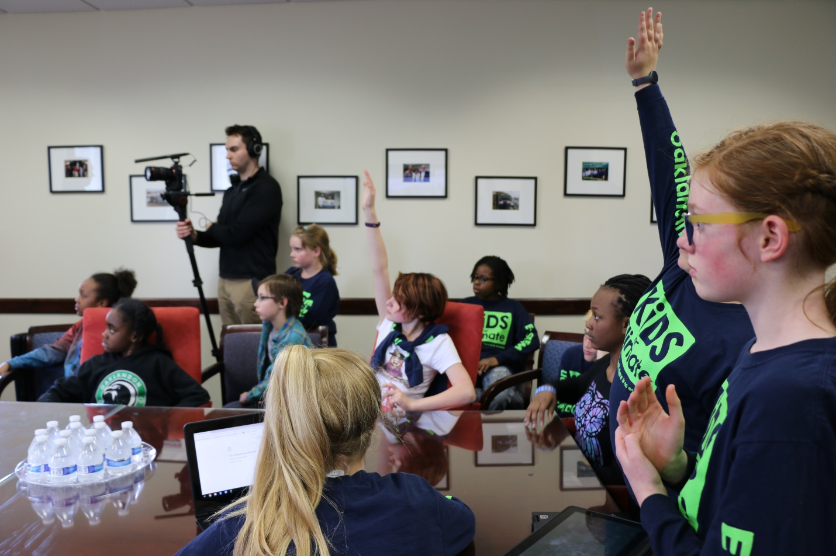
Oaklandon Elementary students visited Mayor Steve Collier April 13 at the Lawrence Government Center to share ideas about conservation. Ms. Laura Getz' STEM students brought questions and suggestions to Mayor Collier during their 90 minute visit. They plan to offer a resolution to the Common Council in May and Mayor Collier plans to present a proclamation for the STEM students' initiatives.

