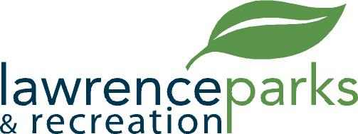

City of Lawrence Board of Parks and Recreation
Regular Meeting
Wednesday, April 12, 2017
6:00 pm
Lawrence Government Center
Public Assembly Room

AGENDA

- Call to Order

- Reading and Acceptance of Minutes from March 8, 2017

- Report from Parks Director

- Board Comments

- Committee Reports

- NEW BUSINESS
  - Jump Start Sports Agreement
  - Central Indiana Amateur Soccer Association (CIASA) Agreement
  - El Grande Soccer League Agreement
  - JB’s Soccer League Agreement
  - Acceptance of Upper Pogues Run Regional Detention Basin

- Upcoming Calendar of Events

- Public Comments

- Adjournment

