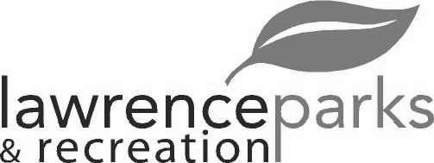
City of Lawrence Board of Parks and Recreation - Regular Meeting
Wednesday, May 9, 2018 – 6:00 pm
Lawrence Government Center
Public Assembly Room

Members present: Jeff Vest, Judy Logsdon, Tom Burns, Shawn Denney and Helen Taylor
Staff: Eric Martin and Dina Gee
Guest: Rick Wells
Meeting was called to order by Jeff Vest at 6:00 pm.
Minutes:
Minutes of the April 11, 2018 meeting were distributed for review and clarification. Jeff entertained a motion to accept the minutes as submitted. Motion was made by Shawn Denney to accept the minutes, seconded by Helen Taylor. Motion carried 5-0.
Reports from Parks Director:
The overtime budget is leveling off now. The revenues are at 42%.
OYO had a water leak in the new concession stand. We will get an estimate to get it repaired.
Eric sent an e-mail to Kona Ice in regards to them being at the Community Park on the weekends to see if they had correct permits from the City.
We have The Marching Pride Color Run scheduled for 8-18-2018.
Board Comment:
Board would like to see the peace circle at Community Park taken up or repaired. They also inquired about the plaque at the flagpole.
Soccer tournament went well. Judy took pictures to show how many people were there.
The Theater at the Fort has not heard back on the grant submitted last month but they did receive a $30,000 grant from Lillys. Plans are to add on to the Sterrett Center patio to connect with the Theater and a handicapped entrance into the Theater.
New Business:
- Land and Water Conservation fund – Deadline June 1, 2018
Eric handed out the information on it for the Reuse Authority
- July 4th – Planning Meeting - Schedule
Eric handed out information with time and dates for invites to the meetings.
- Farmers Market – Schedule
Eric handed out information with time and dates for invites to the meetings.
- Fridays at the Fort – Schedule
Eric handed out information with time and dates for invites to the meetings.
- Fourth of July Fireworks Agreement
Jeff entertained a motion to allow the Mayor to enter into an agreement with Darkstar Pyro for the 4th of July fireworks. Motion was made by Tom Burns to accept, seconded by Shawn Denney. Motion carried 5-0.
Old Business:
- Citizens Group – Sewer Project
Citizens Utilities have the pipe in place and possibly starting the bypass this week. It will take a week to 10 days to complete.
- Lee Road Park – Korb Diamond
Eric and Bob did get dirt leveled out and seeded.
Public Comments:
Rick Wells informed the board that he will not be doing the Car Show for the July 4th this year. He also inquired about who is running the concession stand at the Community Park and if they have a license to do so. Eric stated Virgil is running it and the Board of Health is aware of it. Rick would like a copy of their vendors license.

Adjournment:
Jeff Vest adjourned the meeting at 7:03 p.m.

Secretary Signature: ______________________________________ Date: _____________________________

