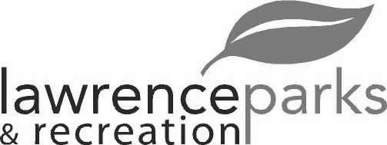
City of Lawrence Board of Parks and Recreation - Regular Meeting
Wednesday, June 12, 2019 – 6:00 pm
Lawrence Government Center
Public Assembly Room

Members present: Jeff Vest, Judy Logsdon, Shawn Denney, Tom Burns and Helen Taylor
Staff: Eric Martin and Dina Gee
Guest:
Meeting was called to order by Jeff Vest at 6:00 pm.
Minutes:
Minutes of the April 10, 2019 meeting were distributed for review and clarification. Jeff entertained a motion to accept the minutes as submitted. Motion was made by Tom Burns to accept the minutes, seconded by Helen Taylor. Motion carried 5-0.
Reports from Parks Director:
The Park’s Master Plan is due this year. Eric will send out letter for quotes. Will also need a sub-committee to oversee it.
We have 4 seasonal employees this year. We hope they will come back next year too.
We would like to add the 4th of July carnival agreement to tonight’s agenda.
Flooring and painting are done at Jenn Park. We have a purchase order for the installation of the new glass basement door, wing walls and slab. A new air conditioner was installed today.
Baumgardner is doing some field studies on the Harmon Way paving to see if they can do it less than the engineer estimates.
Board Comment:
The dead trees are removed at Veteran’s Park and the playgrounds are in. We are having the borders poured this week.
Burns Park has a pot hole that needs to be filled.
There are some dead trees at the Community Park that need to be cut down.
The soccer and football fields need to be reseeded. The trash from soccer games is better this year.
Baseball shelter house at Lee Road Park has been sealed and the roof painted. The windows have been covered up as well.
New Business:
- Acceptance of Quote for Mobile Show Wagon:
After discussion and comparison of quotes, (quotes attached) Jeff entertained a motion to issue a Purchase Order to Century Industries for the construction of a mobile show wagon. Motion was made by Shawn Denney to accept the quote, seconded by Helen Taylor. Motion carried 5-0.
- Resolution #1, 2019 – General Budget Transfer:
Jeff entertained a motion to transfer $130,000 from account 439.010 to account 445.010 for the purchase of the Mobile Show Wagon. Motion was made by Tom Burns to accept the transfer, seconded by Shawn Denney. Motion carried 5-0.
- Primetime Amusement Agreement:
Jeff entertained a motion to enter into an agreement with Primetime Amusements for the City of Lawrence 4th of July Celebration. Motion was made by Helen Taylor to accept the agreement, seconded by Shawn Denney. Motion carried 5-0.
Old Business:
None
Public Comments:
None
Adjournment:
Jeff Vest adjourned the meeting at 6:36 p.m.

Secretary Signature: ______________________________________ Date: _____________________________

