Flag raising ceremony honors Army’s birthday & Flag Day
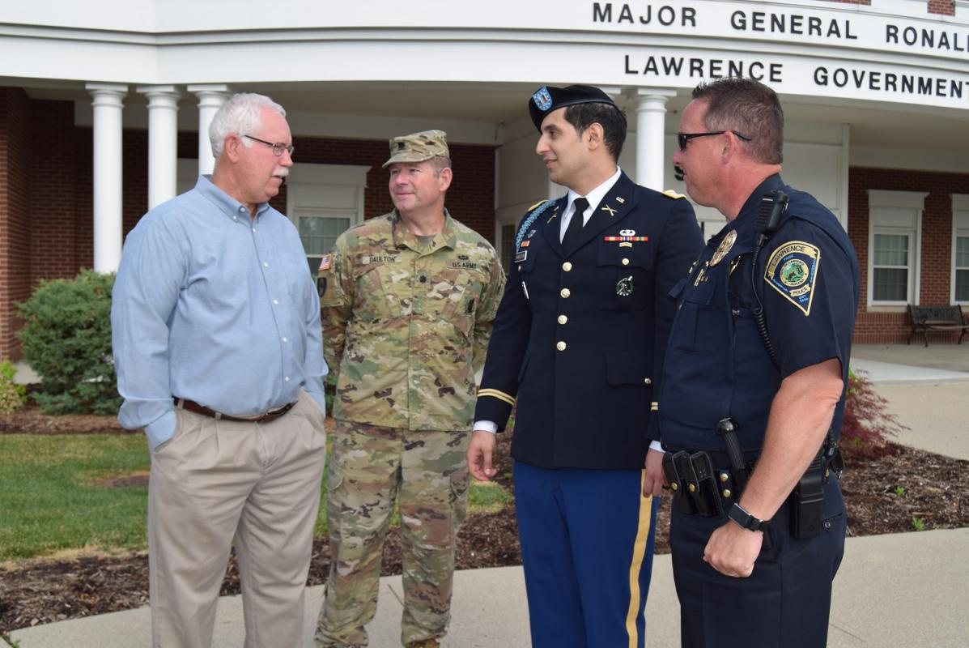
Mayor Steve Collier and Lawrence Police Chief David Hofmann joined current active duty personnel on Flag Day outside the Lawrence Government Center to recognize the U.S. Army's 242nd birthday and to honor the Stars and Stripes on Flag Day.

