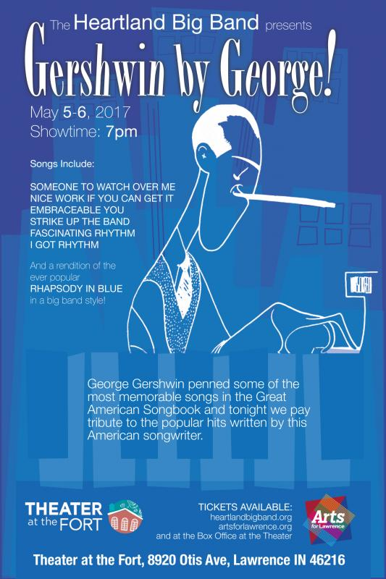s
George & Ira Gershwin penned some of the most memorable songs in the Great American Songbook and on May 5-6 the Theater at the Fort will pay tribute to the popular hits written by this dynamic duo. Songs include SOMEONE TO WATCH OVER ME, NICE WORK IF YOU CAN GET IT, EMBRACEABLE YOU, STRIKE UP THE BAND, FASCINATING RHYTHM, I GOT RHYTHM, and a rendition of the ever popular RHAPSODY IN BLUE in a big band style!
Tickets are $20 for general admission and $17 for students/military with ID.

