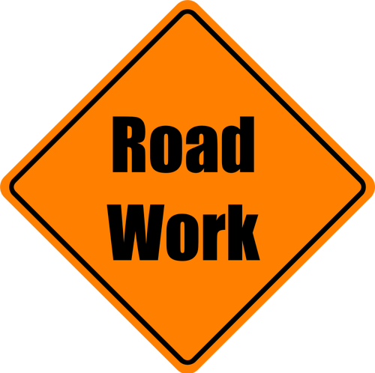
DPW Director of Streets & Solid Waste David Lotts reported 2,016 potholes had been filled so far this spring along City of Lawrence roadways. He said work will continue as weather allows for the holes to be filled. Lotts said the calls to the Mayor’s Action Line assist him in assigning the work to the troubled areas. If you see a pothole on your route, call 317-545-6191 and report its location.

