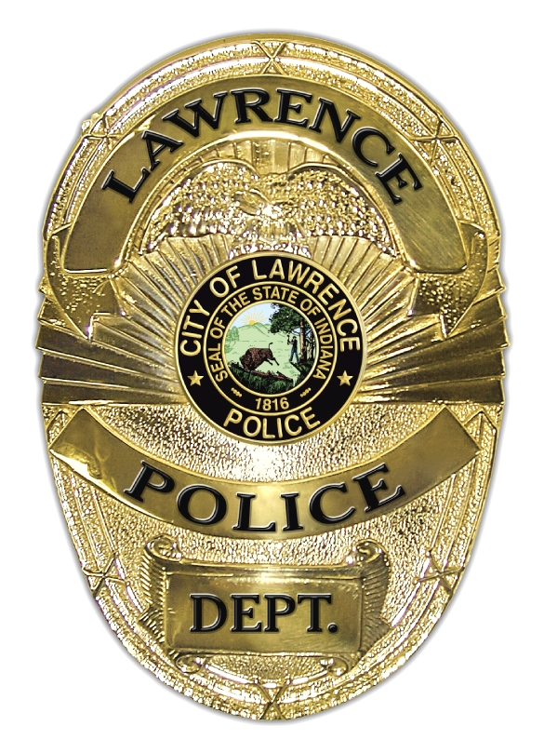

City of Lawrence
Police Department
Tracey D Cantrell
Commander of Administration and Traffic Division
5150 N Post Rd. Lawrence, IN 46226

memorandum
to: Amber Finley & Humphrey Nagila
from: CAPT. Tracey CANTRELL
subject: Disposal of police vehicle
date: 7/28/2026

Ma’am, now I am looking to dispose of non-operable police vehicle that have been parted out and are no longer in running condition. I will contact a local salvage yard to have them come and remove the vehicle to be destroyed. Below is the list of vehicles that can be remove from the city asset list. Once approval for removal, I will contact vendor

- 2013 FORD INTERCEPTOR VIN: 1FAHP2M88DG212819

Thank you for your time,

Tracey D Cantrell
Administration Division Commander

