PROPOSAL NO. 3, 2025

AN ORDINANCE OF THE COMMON COUNCIL OF THE CITY OF LAWRENCE, INDIANA AMENDING TITLE 1, ARTICLE 2, CHAPTER 5 OF THE CODE OF ORDINANCES OF THE CITY OF LAWRENCE, INDIANA

WHEREAS, on October 16, 2024, the Common Council of the City of Lawrence, Indiana (the “Common Council”) adopted Resolution No. 8, 2024, A Resolution Of The Common Council Of The City Of Lawrence, Indiana Concerning Approval Of Collective Bargaining Agreement Between The City Of Lawrence And The Fraternal Order Of Police, Lodge 159 Effective January 1, 2025 (“FOP CBA”);

WHEREAS, on October 16, 2024, the Common Council adopted Resolution No. 9, 2024, A Resolution Of The Common Council Of The City Of Lawrence, Indiana Concerning Approval Of Collective Bargaining Agreement Between The City Of Lawrence And The Lawrence Professional Firefighters’ Association, Local 416 Effective January 1, 2025 (“LPFA CBA”);

WHEREAS, via the FOP CBA and LPFA CBA, the City of Lawrence Indiana agreed to pursue amendments to the following City Ordinances:

§ 1-2-5-2. VACATION POLICY.
§ 1-2-5-3. HOLIDAY LEAVE.
§ 1-2-5-4. SICK LEAVE POLICY.
§ 1-2-5-5. BEREAVEMENT LEAVE POLICY.

WHEREAS, Article IV, Section 14 of the FOP CBA provides as follows:

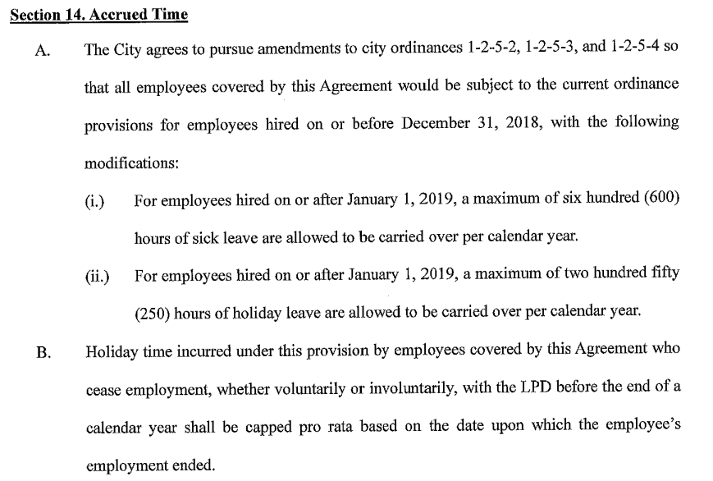

WHEREAS, Article VI, Section 10 of the FOP CBA provides as follows:

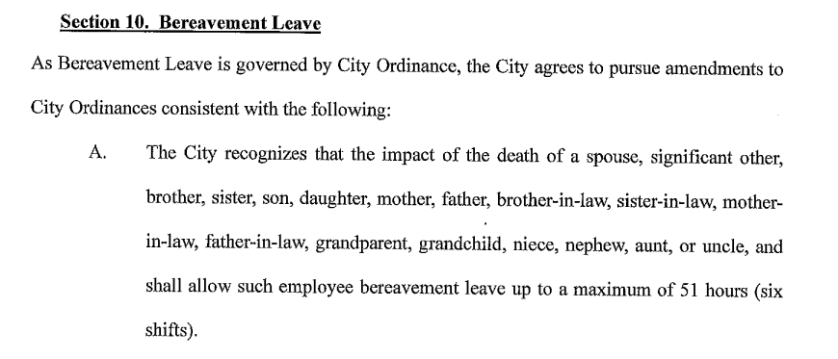

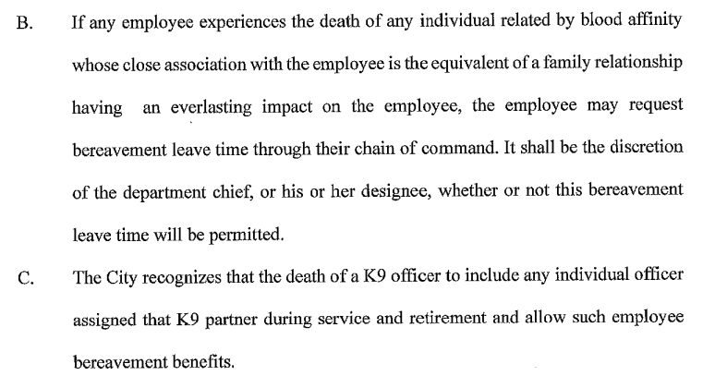

WHEREAS, Article X, Section 8 of the LPFA CBA provides as follows:

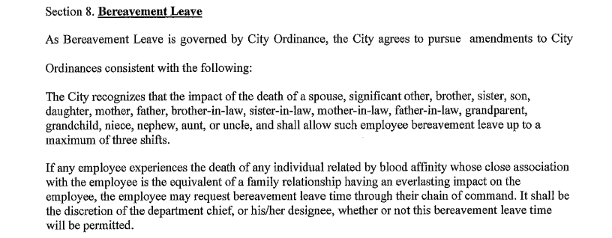

WHEREAS, Article X, Section 13 of the LPFA CBA provides as follows:

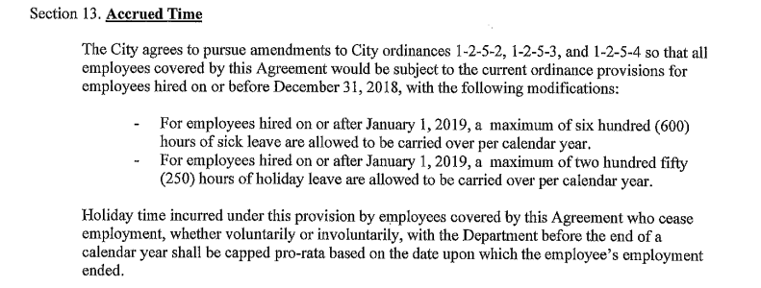

WHEREAS, the Common Council desires to amend Title 1, Article 2, Chapter 5 of the Code of Ordinances of the City of Lawrence, Indiana to reflect the language provided in the FOP CBA and the LPFA CBA concerning accrued time and bereavement leave.

NOW, THEREFORE, BE IT ORDAINED by the Common Council as follows:

SECTION 1. §1-2-5-2. VACATION POLICY is hereby amended as follows:

- Every employee, excluding police officers and firefighters, holding a regular full-time position with the city and hired on or after January 1, 2019 shall be entitled to a specified number of paid vacation hours as provided in division (C). These employees will be eligible for vacation time beginning on the last day of the month following one full month of employment and will accrue additional vacation leave on the last day of every subsequent month thereafter. For determining years of experience, an employee is considered to be an employee with one year of experience on January 1 following that employee's most recent hire date and then considered to have another year of experience on each following January 1 thereafter.

- Every employee hired on or before December 31, 2018 and holding a regular full-time position with the city shall be entitled to a specified number of paid vacation hours as provided in division (C). These employees will accrue vacation leave on January 1 of each year of employment. For purposes of determining years of experience, an employee is considered to be an employee with one year of experience after one year of continuous service and then considered to have another year of experience on each following January 1 thereafter. Police officers and firefighters, regardless of their hire date, shall accrue vacation leave as prescribed in this division (B).

- Vacation time is determined as indicated in the table below:
Years of Service | Annual Hours by Category (employees hired on or before December 31, 2018) |  |  | Monthly Hours by Category (employees hired on or after January 1, 2019)
Years of Service | A | B | C | A | B | C
0 - 1 | - | - | - | N/A | N/A | 6.7
1 - 3 | 96 | 96 | 80 | N/A | N/A | 6.7
4 - 7 | 145 | 168 | 120 | N/A | N/A | 10
8 - 15 | 193 | 240 | 160 | N/A | N/A | 13.3
16 - 19 | 240 | 336 | 200 | N/A | N/A | 16.7
20+ | 288 | 384 | 240 | N/A | N/A | 20
NOTES TO TABLE:
Category A - Annual Hours by Category (employees hired on or before December 31, 2018) - consists of all police officers, regardless of their hire date, as provided in § 1-2-5-2 (B).
Category B - Annual Hours by Category (employees hired on or before December 31, 2018) - consists of all firefighters, regardless of their hire date, as provided in § 1-2-5-2 (B).
Category C - consists of all full-time employees not listed in Category A or B.

SECTION 2. § 1-2-5-3. HOLIDAY LEAVE is hereby amended as follows:

- This division (I) applies only to paid, full-time police officers and firefighters. Due to the need for these public safety employees to work on holidays, all such personnel shall be credited with "bonus hours". These bonus hours shall be accrued in a manner consistent with the collective bargaining agreements with the Fraternal Order of Police Lodge 159 and/or the Lawrence Professional Firefighters Association Local 416. The paid, full-time member of the appropriate department shall be permitted to use these "bonus hours" as additional vacation time. For employees hired on or after January 1, 2019, "bonus hours" generally may not be carried over to the following year. However, an employee may, with the approval of the employee's department head, carry over a maximum of 250 bonus hours from the calendar year in which the "bonus hours" were awarded to the succeeding year. The "bonus hours" must then be utilized in that year and may not be carried over again. The employee's department head shall notify the Controller's Office in writing in the event that the department head approves any carryover request. Department heads shall determine the scheduling of "bonus hours" for all employees of their department. If an employee leaves or otherwise terminates employment with the city, the holiday hours credited will be adjusted to reflect only the time worked past those holidays listed in division (A) above.

SECTION 3. §1-2-5-4. SICK LEAVE POLICY is hereby amended as follows:

(B)(2) For employees hired on and after January 1, 2019, The rules for the accrual of sick leave are the same as those pertaining to the accrual of vacation credit as prescribed in divisions (D) and (E) of § 1-2-5-2 pertaining to vacation leave, except that an employee may, with the approval of the employee's department head, carry over a maximum of 200 hours of sick leave time from the previous calendar year to the succeeding year. The employee's department head shall notify the Controller's Office in writing in the event that the department head approves any carryover request. Upon retirement (with a minimum of 20 years of continuous service) or disability retirement, an employee may redeem no more than 200 hours of sick leave. For police officers and firefighters hired on or after January 1, 2019, a maximum of six hundred (600) hours of sick leave may be carried over per calendar year.

SECTION 4. § 1-2-5-5. BEREAVEMENT LEAVE POLICY is hereby amended as follows:

(A) Any full-time employee is eligible for bereavement leave with pay upon the death of a spouse, brother, sister, son, daughter, mother, father, brother-in-law, sister-in-law, mother-in-law, father-in-law, grandparent, grandchild, niece, nephew or any family member residing in the same household. Any Operations Division police officer or shift firefighter is also eligible for bereavement leave with pay upon the death of an aunt, uncle, or significant other. Any full-time regular employee except shift firefighters, full-time EMTs and paramedics and Operations Division police officers is eligible to receive three days of paid bereavement leave not to exceed 24 hours. Any Operations Division police officer is eligible to receive up to a maximum of 51 hours (six shifts) of bereavement leave. Any full-time EMT or paramedic is eligible to receive one full shift of bereavement leave with pay not to exceed 24 hours. Any shift firefighter is eligible to receive bereavement leave up to a maximum of three shifts. Bereavement leave is to be taken in full shift increments and in consecutive calendar days.

- This division (E) applies only to Operations Division police officers and shift firefighters. If any employee experiences the death of any individual related by blood affinity whose close association with the employee is the equivalent of a family relationship having an everlasting impact on the employee, the employee may request bereavement leave time through their chain of command. It shall be the discretion of the department chief, or his or her designee, whether or not this bereavement leave time will be permitted.

- This division (F) applies only to Operation Division police officers. Upon the death of a K9 officer, the individual officer assigned that K9 partner during service and retirement is allowed employee bereavement benefits as prescribed in §1-2-5-5(A).

SECTION 5. Any resolutions or ordinances or parts thereof in conflict with this Ordinance are hereby repealed and replaced to the extent of the conflict.

SECTION 6. In the event any one or more of the provisions contained in this Ordinance should be held invalid, illegal, or unenforceable in any respect, the validity, legality, and enforceability of the remaining provisions contained herein shall not in any way be affected or impaired and shall remain in full force and effect, and in lieu of each provision that is found to be illegal, invalid, or unenforceable, a provision will be added as a part of this Ordinance that is as similar to the illegal, invalid, or unenforceable provision as may be possible and be legal, valid, and enforceable.

SECTION 7. This Ordinance shall be in full force and effect from and after its adoption by the Common Council and approval by the Mayor.

[Remainder of Page Intentionally Left Blank]

ADOPTED this _______ day of,__________ 2025.

Attest: ___________________ ____________________________
Leatrice Adkisson, Zach Cramer,
City Clerk President

Presented by me to the Mayor of the City of Lawrence, Indiana, this____ day of ______, 2025, at ___________ o’clock _____.m.

_____________________________
Leatrice Adkisson, City Clerk

Presented to me and signed this ____ day of ______, 2025, at ___________ o’clock _____.m.

_____________________________
Deborah Whitfield, Mayor

