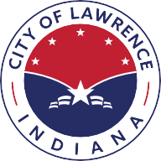
City of
Lawrence
Indiana

September 11, 2025

Board of Public Works and Safety
9001 East 59th Street
Lawrence, IN 46216

RE: Release of Bond and Acceptance of Sidewalks in Spring Run at Winding Ridge, Section 7C

Dear Members,

The City of Lawrence Department of Public Works has inspected the improvement listed above and recommends release of Bond # 641654.

Thank you for your consideration,

Renea Rafala
Director of Public Works

cc: City of Indianapolis

Department of Public Works
9001 East 59th Street, #205 | Lawrence, IN 46216
www.cityoflawrence.org | 317.545-8787

