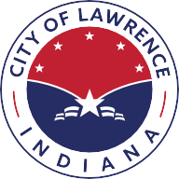
City of
Lawrence
Indiana

September 11, 2025

Board of Public Works and Safety
9001 East 59th Street
Lawrence, IN 46216

RE: Release of Bond and Acceptance of Asphalt Base in Woods at Indian Lake, Section 3

Dear Members,

The City of Lawrence Department of Public Works has inspected the improvement listed above and recommends release of Bond # 60077493.

Thank you for your consideration,

Renea Rafala
Director of Public Works

cc: City of Indianapolis

Department of Public Works
9001 East 59th Street, #205 | Lawrence, IN 46216
www.cityoflawrence.org | 317.545-8787

