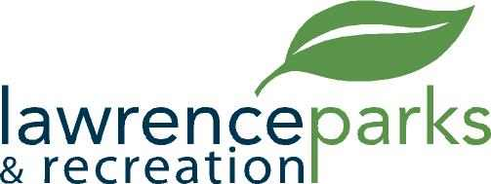

City of Lawrence Board of Parks and Recreation
Regular Meeting
Wednesday, February 8, 2017
6:00 pm
Lawrence Government Center
Public Assembly Room

AGENDA

- Call to Order

- Reading and Acceptance of Minutes from January 11, 2017

- Report from Parks Director

- Board Comments

- Committee Reports

- OLD BUSINESS

  - Fall Creek Softball & Baseball
  - Lawrence Lions Youth Baseball

- NEW BUSINESS
  - Janice Johnson – Deposit Refund Request
  - Jim Joven – OYO – Financials
  - OYO – Resolution #1
  - FC Pride

- Upcoming Calendar of Events

- Public Comments

- Adjournment

