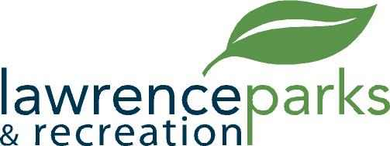

City of Lawrence Board of Parks and Recreation
Regular Meeting
Wednesday, August 9, 2017
6:00 pm
Lawrence Government Center
Public Assembly Room

AGENDA

- Call to Order

- Reading and Acceptance of Minutes from June 14, 2017

- Report from Parks Director

- Board Comments

- Committee Reports

- NEW BUSINESS - None

- OLD BUSINESS -
  - Kim Brown – Jenn Park Refund

- Upcoming Calendar of Events

- Public Comments

- Adjournment

