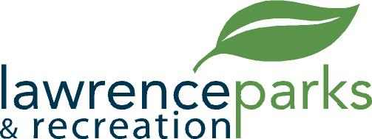

City of Lawrence Board of Parks and Recreation
Regular Meeting
Wednesday, January 9, 2019
6:00 pm
Lawrence Government Center
Public Assembly Room

AGENDA

- Call to Order

- Election of Board Officers

- Reading and Acceptance of Minutes from December 12, 2018

- Report from Parks Director

- Board Comments

- NEW BUSINESS – a. Indianapolis Gaelic Athletic Association – 2019 Facility Agreement.

b. Youth Sports Leagues – 2019 Facility Usage Agreements – Subcommittee meeting dates.

- OLD BUSINESS –
  - None

- Public Comments

- Adjournment

