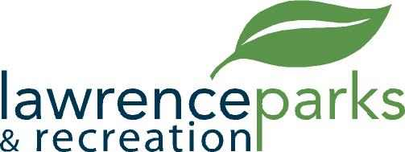

City of Lawrence Board of Parks and Recreation
Regular Meeting
Wednesday, October 9, 2019
6:00 pm
Lawrence Government Center
Public Assembly Room

AGENDA

- Call to Order
- Reading and acceptance of Minutes from September 11, 2019
- Board Comments
- Directors Report
- New Business
  - OYO – End of year update
  - Resolution #2, 2019 – Budget Transfer
  - Acceptance of Explorer Park Playground Equipment Quote
- Public Comment
- Adjournment

