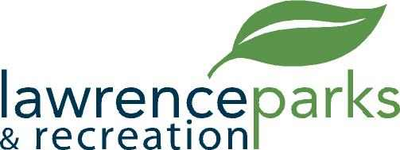

City of Lawrence Board of Parks and Recreation
Regular Meeting
Wednesday, November 14, 2018
6:00 pm
Lawrence Government Center
Public Assembly Room

AGENDA

- Call to Order

- Reading and Acceptance of Minutes from September 12, 2018

- Report from Parks Director

- Board Comments

- NEW BUSINESS –
  - Resolution #3, 2018 – Transfer of Funds within Parks General Budget
  - Declaration of Surplus Equipment and Removal from Inventory
  - Virgil Aldridge – 2018 Baseball and Football League Review

- OLD BUSINESS –
  - None

- Public Comments

- Adjournment

