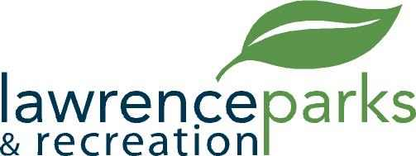

City of Lawrence Board of Parks and Recreation
Regular Meeting
Wednesday, December 11, 2019
6:00 pm
Lawrence Government Center
Public Assembly Room

AGENDA

- Call to Order
- Reading and acceptance of Minutes from November 13, 2019
- Board Comments
- Directors Report
- New Business
  - Acceptance of 2020 Board Meeting Dates
  - Resolution #3, 2019 – A Resolution of the Board of Parks and Recreation to Dispose of Junk Surplus Property
- Public Comment
- Adjournment

