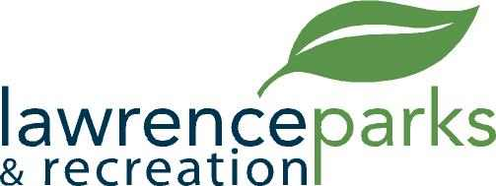

City of Lawrence Board of Parks and Recreation
Regular Meeting
Wednesday, December 12, 2018
6:00 pm
Lawrence Government Center
Public Assembly Room

AGENDA

- Call to Order

- Reading and Acceptance of Minutes from November 14, 2018

- Report from Parks Director

- Board Comments

- NEW BUSINESS –
  - Presentation from Aletha Dunston, Executive Director Fort Harrison Reuse Authority
  - Land and Water Conservation Fund – Additional Documentation
  - 2019 Parks Board Meeting Dates

- OLD BUSINESS –
  - None

- Public Comments

- Adjournment

