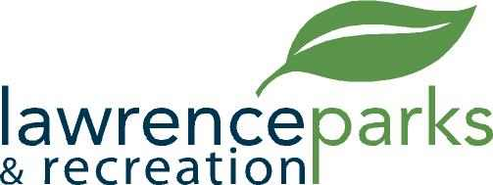

City of Lawrence Board of Parks and Recreation
Special
Meeting
Wednesday, February 15, 2017
5:00 pm
Lawrence Government Center
9001 East 59th Street

AGENDA

- Call to Order

- Review of Certain Special Usage Agreements for 2017

- Adjournment

