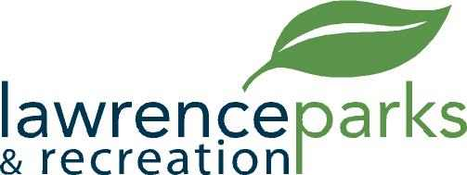

City of Lawrence Board of Parks and Recreation
Regular Meeting
Wednesday, February 20, 2018
6:00 pm
Lawrence Government Center
Public Assembly Room

AGENDA

- Call to Order

- Election of Officers

- Reading and Acceptance of Minutes from December 13, 2017 and January 10, 2018

- Report from Parks Director

- Board Comments

- NEW BUSINESS –

  - Unifirst Agreement
  - GSA Easement Agreement
  - Facility Rental Fee Revision
  - Fall Creek Softball and Baseball Agreement
  - Indianapolis GAA Agreement
  - OYO Year-end Update

- OLD BUSINESS –

- Public Comments

- Adjournment

