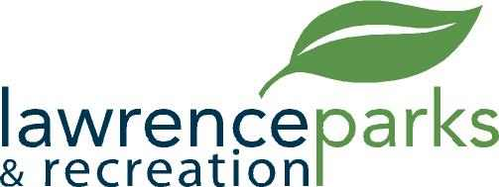

City of Lawrence Board of Parks and Recreation
Regular Meeting
Wednesday, March 14, 2018
6:00 pm
Lawrence Government Center
Public Assembly Room

AGENDA

- Call to Order

- Reading and Acceptance of Minutes from February 20, 2018

- Report from Parks Director

- Board Comments

- NEW BUSINESS –

  - Compass Design LLC
  - Primetime Amusements LLC
  - Facility Rental Fee Revision

- OLD BUSINESS –

- Public Comments

- Adjournment

