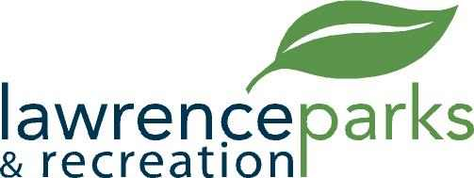

City of Lawrence Board of Parks and Recreation
Regular Meeting
Wednesday, April 10, 2019
6:00 pm
Lawrence Government Center
Public Assembly Room

AGENDA

- Call to Order

- Reading and Acceptance of Minutes from March 13, 2019

- Report from Parks Director

- Board Comments

- NEW BUSINESS –
  - Approval of a contract with Shrewsberry

- OLD BUSINESS –
  - None

- Public Comments

- Adjournment

