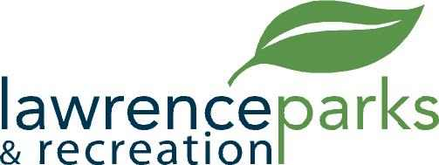

City of Lawrence Board of Parks and Recreation
Regular Meeting
Wednesday, May 9, 2018
6:00 pm
Lawrence Government Center
Public Assembly Room

AGENDA

- Call to Order

- Reading and Acceptance of Minutes from April 11, 2018

- Report from Parks Director

- Board Comments

- NEW BUSINESS –
  - Land and Water Conservation fund – Deadline June 1, 2018
  - July 4th – Planning Meeting – Schedule
  - Farmers Market – Schedule
  - Fridays at the Fort – Schedule

- OLD BUSINESS –
  - Citizens Group – Sewer Project
  - Lee Road Park – Korb Diamond

- Public Comments

- Adjournment

