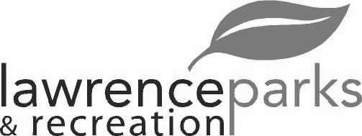
City of Lawrence Board of Parks and Recreation - Regular Meeting
Wednesday, April 10, 2019 – 6:00 pm
Lawrence Government Center
Public Assembly Room

Members present: Jeff Vest, Tom Burns and Helen Taylor
Staff: Eric Martin and Dina Gee
Guest:
Meeting was called to order by Jeff Vest at 6:00 pm.
Minutes:
Minutes of the March 13, 2019 meeting were distributed for review and clarification. Jeff entertained a motion to accept the minutes as submitted. Motion was made by Tom Burns to accept the minutes, seconded by Helen Taylor. Motion carried 3-0.
Reports from Parks Director:
We have a big expenditure at Jenn Park. We are regrading around the lower level of Jenn Park and replacing the retaining wall. We will put in for painting the outside later in the year. Also, need a new pump for pond.
The new playground equipment at Veterans Park should be done this week and some trees have been cut down as well.
April 13, 2019 is opening day for OYO.
April 20, 2019 at 10 am is the Spring Fling at the Community Park.
April 27, 2019 is the opening day for Fall Creek Little League and Lawrence Park.
Board Comment:
The Harmon Way road project had core samplings done. There is little to no base so and increase in expense is expected. The funds are coming out of the City Budget’s rainy day and cost savings from health care. They will send out a notice for bids and the opening of the bids will be April 25, 2019.
The contractor with the water tower will come out within a couple of weeks and clean up and landscape.
The Parks Department has one full time position open and 3-4 seasonal help positions.
New Business:
None
Old Business:
None
Public Comments:
None
Adjournment:
Jeff Vest adjourned the meeting at 6:13 p.m.

Secretary Signature: ______________________________________ Date: _____________________________

