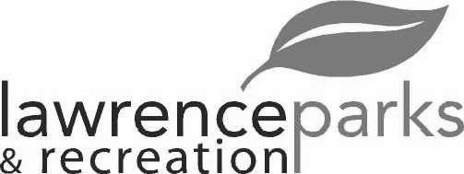
City of Lawrence Board of Parks and Recreation – Regular Meeting
Wednesday, March 13, 2019 – 6:00 pm
Lawrence Government Center
Public Assembly Room

Members Present: Jeff Vest, Tom Burns and Shawn Denney.
Staff Present: Eric Martin
Guest Present: Judy Byron and Mark Lemon
Meeting called to order at 6:00pm
President Vest altered the agenda to move New Business first on the agenda.
New Business:
FC Pride – 2019 Facility Usage Agreement – After much discussion, a motion was made by Tom Burns to enter into an agreement to include 30,000 dollars of improvements during the course of the agreement, seconded by Shawn Denney, motion passed 3-0. Additional discussion included, removal of outdated signage, new nets, repair of fencing and economic impact of soccer.
Lawrence Park Baseball – 2019 Facility Usage Agreement – A motion was made by Tom Burns to amend the agreement to $2,400 improvements over the course of the agreement, Shawn Denney, seconded the amendment, Tom Burns made a motion to accept the amended version, seconded by Shawn Denney, motion passed 3 – 0.
Fall Creek Baseball and Softball – 2019 Facility Usage Agreement - A motion to approve the agreement was made by Shawn Denney, seconded by Tom Burns, motion passed 3 -0.
Old Business:
Lawrence Township Lacrosse League (LTLL) – 2019 Facility Usage Agreement: A motion was made by Jeff Vest to place the agreement back on the agenda, seconded by Tom Burns, motion carried 3-0 to place back on the table. Motion was by Shawn Denney to approve the agreement with LTLL now that proof of insurance was filed, seconded by Tom Burns, motion carried 3-0.
Public Comment:
Judy Byron, Executive Director of Arts for Lawrence discussed with the Board that the City and AFL have entered into an agreement to develop the cultural campus with the proceeds of the Lilly Grant. The planning process is ongoing with the development of Placemaking Council. Judy asked the Board for volunteers to help determine the programming and scheduling of the Sterrett Center. Jeff asked the timeline of the project, Judy said all five phases should be completed by January 2023. Four more meetings will be scheduled to obtain public comment.
Reading and Acceptance of Minutes from February 13, 2019:
A motion was made by Shawn Denney to accept the minutes as distributed, seconded by Tom Burns, motion carried 3-0.
Report from Parks Director:
None.
Board Comments:
None.
Motion was made by Jeff Vest to adjourn, seconded by Tom Burns, motion carried 3-0.
Adjourned at 6:50pm

