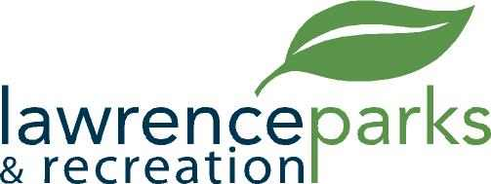

City of Lawrence Board of Parks and Recreation
Regular Meeting
Wednesday, October 11, 2017
6:00 pm
Lawrence Government Center
Public Assembly Room

AGENDA

- Call to Order

- Reading and Acceptance of Minutes from August 9, 2017

- Report from Parks Director

- Board Comments

- Committee Reports

- NEW BUSINESS
  - Mural – Community Park
  - Virgil – Football – Yearend Report
  - Facility Usage Agreement with Glamnaires Dance LLC
  - Acceptance of Donation from Girl Scout Troup#1890

- Upcoming Calendar of Events

- Public Comments

- Adjournment

