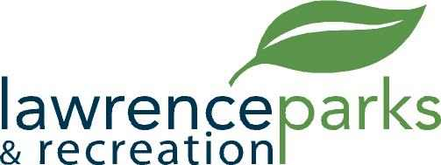

City of Lawrence Board of Parks and Recreation
Regular Meeting
Wednesday, February 13, 2019
6:00 pm
Lawrence Government Center
Public Assembly Room

AGENDA

- Call to Order

- Reading and Acceptance of Minutes from January 9, 2019

- Report from Parks Director

- Board Comments

- NEW BUSINESS –
  - Lawrence Township Lacrosse League (LTLL) Burns Park Agreement
  - Fall Creek Softball and Baseball

- OLD BUSINESS –
  - None

- Public Comments

- Adjournment

