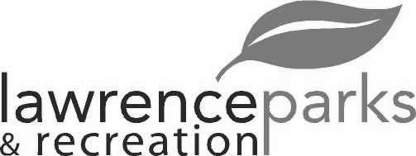
City of Lawrence Board of Parks and Recreation - Regular Meeting
Wednesday, August 9, 2017 - 6:00 pm
Lawrence Government Center
Public Assembly Room

Members present: Judy Logsdon, Tom Burns, Shawn Denney and Helen Taylor
Staff: David Johnson, Eric Martin and Dina Gee
Other:
Guest: Kimberly Brown
Meeting was called to order by Judy Logsdon at 6:00 pm.
Minutes:
Minutes of the June 14, 2017 meeting were distributed for review and clarification. Judy entertained a motion to accept the minutes as submitted. Motion was made by Tom Burns to accept the minutes, seconded by Judy Logsdon. Motion carried 4-0.
Reports from Parks Director:
The department has been working on the budget for 2018. It seems like it is going to be about the same as it was last year. We have been talking about the financing part for the improvements in the infrastructure throughout the Parks.
The doors at the Community Center are in the process of being replaced.
The general budget is going to be close on the utilities, but there is some allowance in the non-reverting to cover. The revenue side is pretty close.
Lawrence Central girls and boys are using the soccer fields at Lawrence Park this year.
Board Comment:
Tom Burns inquired again about the ditch at the Community Park. Eric explained that the Utility Department sent out letters for request for quotes for the remediation there. Also, Eric is going to talk to DPW to see if they will trim the ditch line back some.
Registration for fall ball has begun. The Special Olympics are practicing at the Community Park fields.
Tom noted a few things that needed to addressed at the Community Park…..The Peace Circle has bricks missing and needs to be weeded. Also, the shrubs along the South walkway at the Soccer Fields need to be trimmed.
The Board determined that a sub-committee needs to be formed to discuss and meet with Indy Parks regarding the park tax levy.
Committee Meeting:
July 4th Festival was a big success. The carnival brought in over $20,000. There was an issue with crowd control but the vendor suggested temporary fencing and only paying customers to be allowed in.
New Business: None
Old Business:
- Kim Brown – Jenn Park Refund
After some discussion about the complaints Ms. Brown had, the Board determined that she did have her event at Jenn Park as planned and Ms. Brown is not entitled to any refunds. Judy entertained a motion that none of the rental fees be refunded. Motion was made by Helen Taylor to accept the no refunds, seconded by Tom Burns. Motion carried 4-0.
Upcoming Calendar Events:
August 11, 2017 is the last Fridays at the Fort.
August 12, 2017 is Safety Day at Fire Station 40 starting at 10:00 a.m. At 11:30 the wing eating contest will be held.
August 19, 2017 The School Color run will take place at the Community Park. It is a fundraiser for the Lawrence Township Foundation.
Public Comments:
Adjournment:
Judy Logsdon adjourned the meeting at 6:45 p.m.

Secretary Signature: ______________________________________ Date: _____________________________

