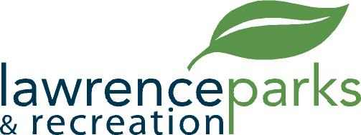

City of Lawrence Board of Parks and Recreation
Regular Meeting
Wednesday, March 8, 2017
6:00 pm
Lawrence Government Center
Public Assembly Room

AGENDA

- Call to Order

- Reading and Acceptance of Minutes from February 8, 2017

- Report from Parks Director

- Board Comments

- Comments by Carlton Curry

- Committee Reports

- OLD BUSINESS
  - Lawrence Lions Youth Baseball - Signature
  - Lawrence Youth Football - Signature
  - FC Pride Agreement - Signature
  - LSC Agreement - Signature

- NEW BUSINESS
  - Indianapolis GGA Agreement

- Upcoming Calendar of Events

- Public Comments

- Adjournment

