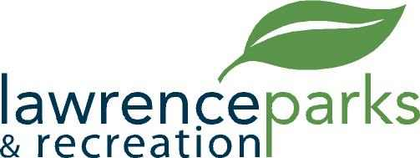

City of Lawrence Board of Parks and Recreation
Regular Meeting
Wednesday, June 13, 2018
6:00 pm
Lawrence Government Center
Public Assembly Room

AGENDA

- Call to Order

- Reading and Acceptance of Minutes from May 9, 2018

- Report from Parks Director

- Board Comments

- NEW BUSINESS –
  - Arts for Lawrence Grant
  - Sterrett Center Interior Remodel – Approval of Scope of Work and Vendor Selection

- OLD BUSINESS –
  - Community Park Sewer Repair – Update
  - Land and Water Conservation Fund - Update

- Public Comments

- Adjournment

