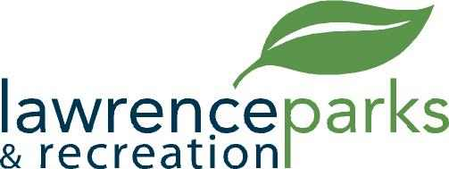

City of Lawrence Board of Parks and Recreation
Soccer Committee
Friday, March 17, 2017
3:00 pm
Robert Sterrett Center
8950 Otis Ave.

AGENDA

- Call to Order

- Discussion concerning Season Ending Financial Report format

- Status of Lawrence Soccer Complex Incorporated

- Discussion of LSC concession modification

- Other topics determined by the Chairman

- Adjournment

