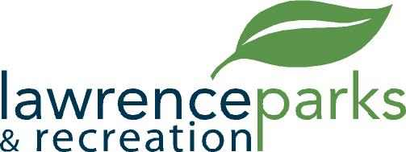

City of Lawrence Board of Parks and Recreation
Regular Meeting
Wednesday, July 10, 2019
6:00 pm
Lawrence Government Center
Public Assembly Room

AGENDA

- Call to Order
- Reading and acceptance of Minutes from June 12, 2019
- Board Comments
- Directors Report
- Old Business – None
- New Business
  - Lawrence Baseball – 2019 Season Review
  - Oaklandon Youth Organization – Season Review
- Public Comment
- Adjournment

