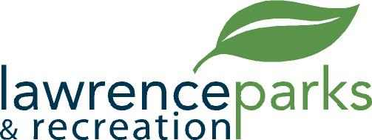

City of Lawrence Board of Parks and Recreation
Regular Meeting
Wednesday, January 10, 2018
6:00 pm
Lawrence Government Center
Public Assembly Room

AGENDA

- Call to Order

- Election of Officers

- Reading and Acceptance of Minutes from December 13, 2017

- Report from Parks Director

- Board Comments

- Committee Reports

- NEW BUSINESS –

  - GSA Easement Agreement

- OLD BUSINESS –

- Public Comments

- Adjournment

