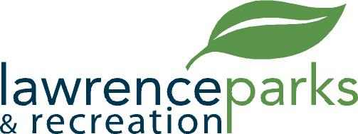

City of Lawrence Board of Parks and Recreation
Regular Meeting
Wednesday, June 14, 2017
6:00 pm
Lawrence Government Center
Public Assembly Room

AGENDA

- Call to Order

- Reading and Acceptance of Minutes from May 10, 2017

- Report from Parks Director

- Board Comments

- Committee Reports

- NEW BUSINESS
  - Kim Brown – Jenn Park Refund
  - Antojitos Rojas Y Mas – Food Truck – Special Usage Agreement

- Upcoming Calendar of Events

- Public Comments

- Adjournment

