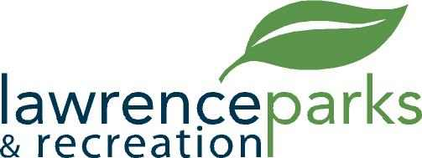

City of Lawrence Board of Parks and Recreation
Regular Meeting
Wednesday, December 13, 2017
6:00 pm
Lawrence Government Center
Public Assembly Room

AGENDA

- Call to Order

- Reading and Acceptance of Minutes from November 8, 2017

- Report from Parks Director

- Board Comments

- Committee Reports

- NEW BUSINESS –

  - 2018 Meeting Dates

- OLD BUSINESS –

- Upcoming Calendar of Events

- Public Comments

- Adjournment

