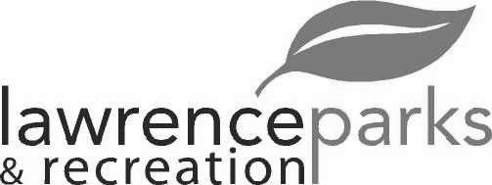
City of Lawrence Board of Parks and Recreation - Regular Meeting
Wednesday, June 14, 2017 - 6:00 pm
Lawrence Government Center
Public Assembly Room

Members present: Jeff Vest, Tom Burns and Helen Taylor
Staff: David Johnson, Eric Martin and Dina Gee
Other:
Guest: Kimberly Brown
Meeting was called to order by Jeff Vest at 6:00 pm.
Minutes:
Minutes of the May 10, 2017 meeting were distributed for review and clarification. Jeff entertained a motion to accept the minutes as submitted. Motion was made by Tom Burns to accept the minutes, seconded by Helen Taylor. Motion carried 3-0.
Reports from Parks Director:
Revenue reports are good but we did have to transfer funds from one account to another for softball awards. With the warmer weather, we will also need to watch the utility funds. We have traded in a couple of our trailers on a new trailer for the hauling of the mowers.
We will start meeting sometime in July to talk about the 2018 budget.
We had a meeting with MSDLT and Fall Creek concerning the appearance and up keep of the senior field at Lee Road Park. There will be another meeting next month.
Board Comment:
The summer camp program did not happen due to lack of participants.
Tom Burns would like to know if the Public Works Department is planning on picking up the trees that they cut down in the Community Park.
The Park’s Department is planning on removing the graffiti at the Skate Park before the July 4th festival.
The repairs at Explorer Park have been completed but it does need new play equipment.
Pogues Run design is nearing 60% completion. They are needing specification on what type of turf and trees the Board would like to see there.
Committee Meeting:
LSC and FC Pride spring season is over. Jeff would like to set up a meeting with both organizations regarding some conflicts in the usage agreements.
New Business:
- Kim Brown – Jenn Park Refund
- Tabled til next month to get input from other Board members.
- Antojitos Rojas Y Mas – Food Truck – Special Usage Agreement
- Eric asked the Board to deny the Usage Agreement for the food truck. Jeff entertained a motion to deny the Usage Agreement between the City of Lawrence and Antojitos Rojas Y Mas. Motion was made by Tom Burns to accept the deny of the Usage agreement, seconded by Helen Taylor. Motion carried 3-0.
Upcoming Calendar Events:
Farmer’s Market has been a success. They will have new vendors and music at the next event.
The carnival starts June 29th and will run to July 5th.
The Wingin It contest will be June 30th at the Sterrett Center.
DFAS will host their picnic at the Community Park on June 30th.
Public Comments:
Adjournment:
Jeff Vest adjourned the meeting at 6:49 p.m.

Secretary Signature: ______________________________________ Date: _____________________________

