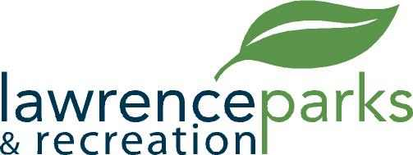

City of Lawrence Board of Parks and Recreation
Regular Meeting
Thursday, August 9, 2018
6:00 pm
Lawrence Government Center
Public Assembly Room

AGENDA

- Call to Order

- Reading and Acceptance of Minutes from June 13, 2018

- Report from Parks Director

- Board Comments

- NEW BUSINESS –
  - Resolution #2, 2018 – A resolution concerning a memorandum of understanding between the City of Lawrence and Arts for Lawrence
  - Memorandum of Understanding between the City of Lawrence Department of Park and Recreation and Partnership for Lawrence, Inc. dba Arts for Lawrence
  - Budget Review and Process for 2019

- OLD BUSINESS –
  - Land and Water Conservation Fund – Update
  - Farmers Market - Schedule

- Public Comments

- Adjournment

