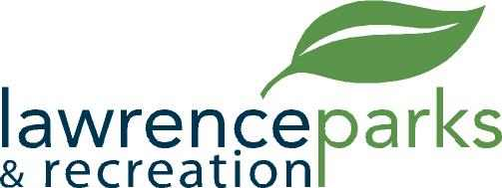

City of Lawrence Board of Parks and Recreation
Regular Meeting
Wednesday, September 12, 2018
6:00 pm
Lawrence Government Center
Public Assembly Room

AGENDA

- Call to Order

- Reading and Acceptance of Minutes from August 9, 2018

- Report from Parks Director

- Board Comments

- NEW BUSINESS –
  - Acceptance of Quote for Playgrounds @ Veterans Memorial Park
  - Budget Review and Process for 2019

- OLD BUSINESS –
  - None

- Public Comments

- Adjournment

