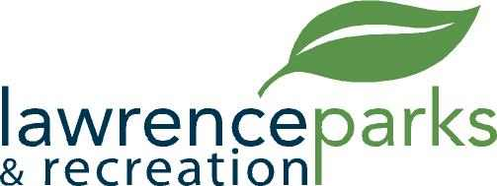

City of Lawrence Board of Parks and Recreation
Regular Meeting
Wednesday, May 10, 2017
6:00 pm
Lawrence Government Center
Public Assembly Room

AGENDA

- Call to Order

- Reading and Acceptance of Minutes from March 8, 2017

- Report from Parks Director

- Board Comments

- Committee Reports

- NEW BUSINESS
  - Carlton Curry – Fees
  - I Heart Media Proposal

- Upcoming Calendar of Events

- Public Comments

- Adjournment

