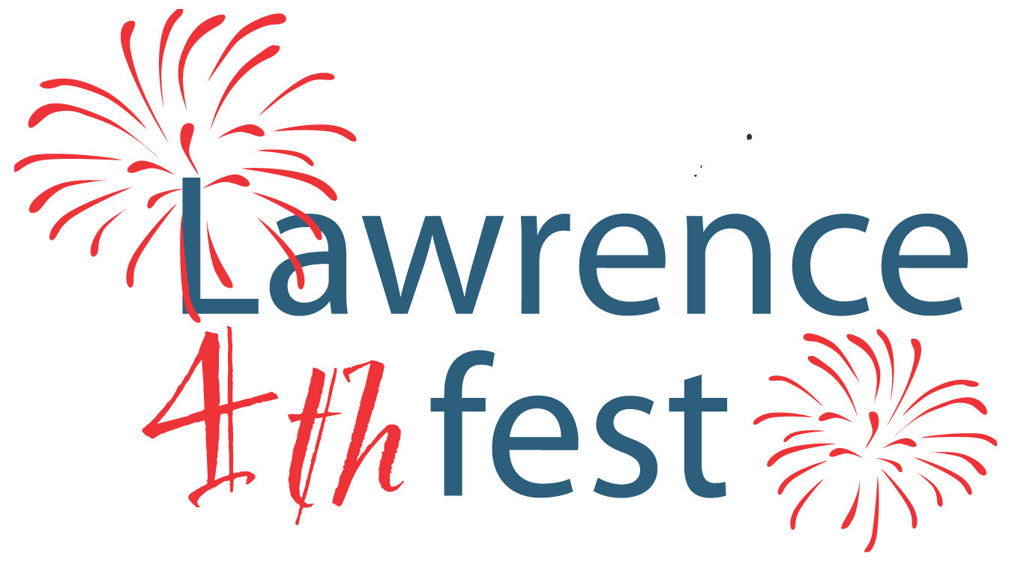

City of Lawrence

Independence Day Parade Application

Wednesday, July 4, 2018 – 10:00 a.m.
Line up begins at 9:00 a.m. at Harrison Hill Elementary – 7510 E. 53rd Street
Parade ends at Lawrence Community Park – 5301 N. Franklin Road

Please return this form no later than June 22, 2018 to guarantee a position in the parade.

Name :_____________________________________________________

Organization:_______________________________________________

Address:___________________________________________________

Daytime Phone: _____________________________________________

Email Address:______________________________________________

Car, Float, Etc.:______________________________________________

Length of Float or Vehicle:_____________________________________

Will you have walkers? No ___
Yes ____ # of Walkers _____
(Please limit the number of walkers to 8 or less.)

The Lawrence Independence Day Parade is July 4th, 2018. All entries must have a patriotic theme/flag decoration/bunting, etc.

Flyers & brochures are not allowed along the parade route as they become trash along the road. Limit your handouts to actual items!
Signs will not be provided. If you want a sign, you will need to provide your own.

Return completed form via fax or mail:
Lawrence Parks Department – 8950 Otis Avenue – Lawrence, IN 46216
Fax to: 317-549-6410
For questions please call 317-549-4815. This form may also be completed online at www.cityoflawrence.org.

